Currency Exchange

James LeBlanc

Company Background

December 4, 2015

Table of Contents

Company Background 2

Management Team 3

Support Staff 4

Organization Chart 5

References 5

# Company Background

**Name of Company**

Currency Exchange

**Address**

New York, NY

**Legal Structure**

LLC – Currency Exchange is a new company owned by President and CEO James LeBlanc. The exchange will operate under the BitLisence issued by New City and the money exchange licence issued by the fed. The Chief Compliance officer will coordinate the aquizition and retention of the appropieae licenses

**Intellectual Assets and Protection**

The companies Logo and Name which will appear on all marketing materials and throughout the web portal will be trademarked. Currency exchange will design build and maintain comprehensive proprietary software platform to operate the exchange. We will also design and maintain a web portal with versions for PC’s, tablets and Smartphones. All software will be copy writted to the exchange

## Management Team

**James LeBlanc, President and CEO**

**Chief Financial Officer**

**Job Description:** This person is in charge of the money. Responsibilities will include maintain all company assets, facilitate the purchase and sale of assets, control financial aspect of contracts with key partners(e.g., datacenter, Internet service provider, commercial bank)

**Education/Experience Required:** BA accounting or other financial discipline, 7 year experience working in a financial compasity.

**Chief Information Officer**

**Job Description:** This person is in charge of the Information system. Job duties will include setting up contracts with IT service providers, Management the development and maintenance of proprietary software. In charge of information security.

**Education/Experience Required:** BA in Information System Management, 7 year experience working as a IT professional.

**Chief Technology Officer**

**Job Description:** This person is in charge researching and finding new technologies to help the business. He/she will oversee the development teams. He/she will install and maintain required technology systems including (e.g., computers, networking, software, printers and other periferals)

**Education/Experience Required:** BA in Information System Management, 7 year experience working as a IT professional including experience implementing software solutions and managing software development efforts.

**Chief Operation Officer**

**Job Description:** This person is responsible to keep things going. He/she will run the company in the abscne of the CEO. Principle functions include dealing with customers, driving marketing efforts, handeling all non technical office requirements. Manage call center.

**Education/Experience Required:** BA in Business mangement, 5 year management experience.

**Chief Compliance Officer**

**Job Description:** This person is responsible to keep the exchange complient will all legal requirements. He/she will deal with all legal challenges relating to the exchange. Must keep current will all legal regulations having to do with crypto currencies and money exachangers.

**Education/Experience Required:** Legal degree plus 7 years experience as a working attorney.

## Support Staff

**Customer Service representative**

**Job Description:** This person will deal with customer request and complaints.

**Education/Experience Required:** Associate degree. With 1 year customer service experience

**Software Developer**

**Job Description:** Design and build software.

**Education/Experience Required:** Associate degree. With 3 software designing experience

## Organization Chart

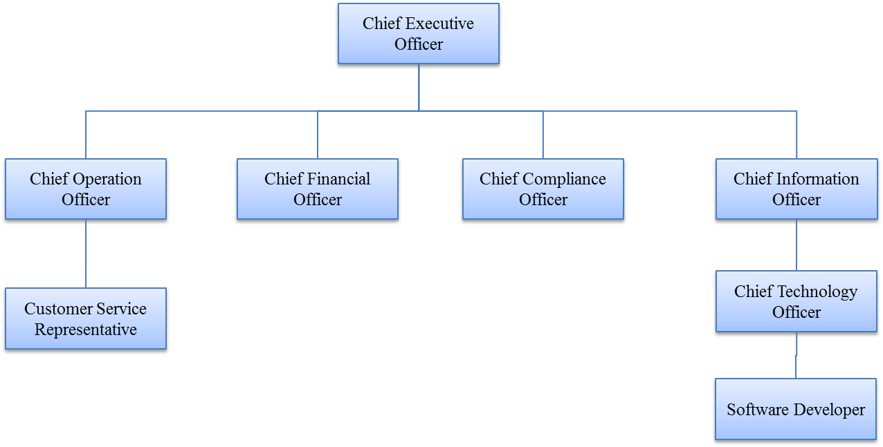

# References